**List,Start,Stop,Restart Containers**

**Step 1 : List all the running Containers**

# docker ps

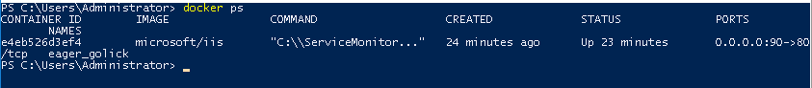

**Step 2 : List all the Containers**

# docker ps -a

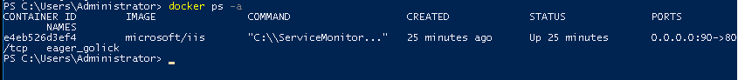

**Step 3 : To Stop the Container (your Container ID)**

# docker stop e4eb526d3ef4



**Step 4 : To list all running containrs**

# docker ps



**Step 5 : To list all the Container**

# docker ps -a

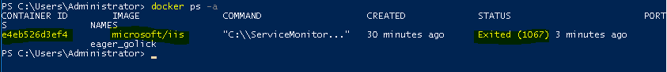

**Step 6 : To Start the Container (your Container ID)**

# docker start e4eb526d3ef4



**Step 7 : Now list all the running containers**

# docker ps

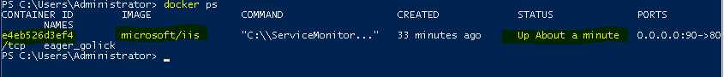

**Step 8 : To pause the Container (your Container ID)**

# docker pause e4eb526d3ef4



**Step 9 : list the running containers**

# docker ps

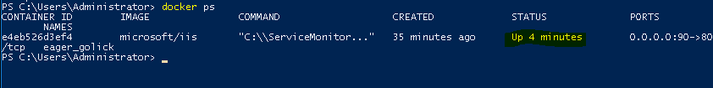

**Step 10 : To Stop the Container (your Container ID)**

# docker restart e4eb526d3ef4



**Step 11 : To Stop the Container (your Container ID)**

# docker ps

